Student Name: Student ID:

**PHYSICAL EDUCATION**

**KNOWLEDGE PACKET 1**

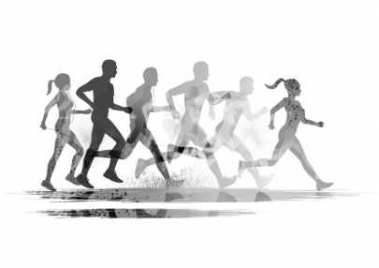For students completing their 1st non-activity-based competency credit for PE.

**Washington State Physical Education**

**Standards Checklist**

**The following document explains how each portion of the knowledge activity connects to a Washington State Physical Education learning standard.**

**Physical Education Standard 1:** *Students will demonstrate competency in a variety of motor skills and movement patterns.* (Met by participating in your self-selected activity*)*

**Physical Education Standard 2**: *Students will apply knowledge of concepts, principles, strategies and tactics related to movement and performance.* (Met by completing the Sport/Activity Analysis and Individual Fitness Plan in packet 1)

**Physical Education Standard 3:**  *Students will demonstrate the knowledge and skills to achieve and maintain a health-enhancing level of physical activity and fitness.* (Met by completing Individual Fitness Plan in packet 1 and completing Fitness for a Lifetime program in packet 2)

**Physical Education Standard 4:** *Students will exhibit responsible personal and social behavior that respects self and others*. (Met by participating in your self-selected activity)

**Physical Education Standard 5:** *Students will recognize the value of physical activity for health, enjoyment, challenge, self-expression, and social interaction.* (Met by completing the Sport/Activity Analysis in packet 1 and Fitness for a Lifetime program in packet 2)

**Application for Competency-Based Program to Meet   
Non-Activity-Based Physical Education Credit Requirement**

|  |
| --- |
| **Student Information**  Name Student # |
|  |
| School Grade 9 10 11 12 |
|  |
| Address |
| (Street, City, Zip) |
| Phone |
|  |
| Reason applying for program: ___________________________________________________________________  ___________________________________________________________________________________________ |
|  |
| I wish to meet the PE requirement through non-activity-based competency credit. I understand that if I do not complete the documentation or reflection, I will either need to repeat the process or take a PE course for credit. I understand this process will fulfill a .5 PE credit requirement for graduation. I understand that per the Washington State Board of Education: *The physical education requirement is a core subject area requirement that may not be waived. Individual students may be excused locally from participating in the fitness portion of physical education "on account of physical disability, employment, religious belief, or because of participation in directed athletics or military science and tactics or for other good cause.” (*[*RCW 28A.230.050*](http://apps.leg.wa.gov/rcw/default.aspx?cite=28A.230.050)*). WAC 180-51-067, WAC 180-51-068, and WAC 180-51-210, clarify that such excused students shall be required to demonstrate proficiency/competency in the knowledge portion of the physical education requirement.*  Student Signature Date  Parent/Guardian Signature Date |
| The non-activity-based competency credit for physical education may only be completed with prior approval by principal.  Principal Signature Date |
|  |
| **To be completed upon submission of this packet** |
| * The student has successfully completed the knowledge portion to earn .5 credit of the PE requirement. |
|  |
| Principal Signature Date |

**Sport/Activity Analysis**

**The following assignment must be completed along with the Cognitive Assessment**.

This is your opportunity to analyze your sport or activity in relationship to the five components of fitness. Written below are definitions of the five components of fitness with example activities that will assist you in the activity analysis portion of the packet.

**Cardio-Respiratory Endurance** - the ability of the heart, lungs, and blood vessels to use and send fuel and oxygen to the body's tissues during long periods of moderate-to-vigorous activity

* + **Activities:** Running, jogging, walking, bicycling, swimming or other activities where you are in your target heart rate zone for a minimum of 20 minutes.

**Flexibility** - the ability to move the joints through a full range of motion

* + **Activities:** Stretching, Yoga, Tai-Chi, or other activities that increase or sustain your range of motion of your joints.

**Muscular Endurance** - the ability of the muscles to perform physical tasks over a period of time without becoming fatigued

* + **Activities:** Weight training with light weight for 12-15 reps; push-ups, sit-ups, crunches, leg lifts, squats, body weight resistance exercises.

**Muscular Strength** - the amount of force a muscle can exert

* + **Activities:** Weight training with heavy weight (60-75% of your 1 rep max) for 7-10 reps, exercises with additional resistance added by another person or additional weights. Body weight may be used for this depending on the exercise and your ability to do that exercise. Example: Pull-ups.

**Body Composition** - a measure of ones percentage of fat body mass compared to lean body mass

* + **Activities:** Exercise and attention to a healthy diet helps people reach a healthy Body Composition.

**Sport/Activity Analysis**

**Using the five components of fitness definitions above and prior knowledge in Physical Education 1 classes describe how your activity promotes or improves each component of fitness. Example exercises would be good to add in your description. Indicate if you think your activity is strong or weak in any of the components. Some components of fitness may be focused on more within your sport or activity than others.**

**Cardio-Respiratory Endurance**: ______________________________________________________________________________________________________________________________________________________________________________________________________________________________________________________________________________________________________________________________________________________________________________________________________   
Circle one: Strong Weak

**Flexibility:** ______________________________________________________________________________________________________________________________________________________________________________________________________________________________________________________________________________________________________________________________________________________________________________________________________   
Circle one: Strong Weak

**Muscular Endurance:**

______________________________________________________________________________________________________________________________________________________________________________________________________________________________________________________________________________________________________________________________________________________________________________________________________   
Circle one: Strong Weak

**Muscular Strength:**

______________________________________________________________________________________________________________________________________________________________________________________________________________________________________________________________________________________________________________________________________________________________________________________________________   
Circle one: Strong Weak

**Body Composition: (Indicate how you think your body composition will change and or improve with your given activity and describe why.)**

____________________________________________________________________________________________________________________________________________________________________________________________________________________________________________________________________________________________________________________________________________________________________________________________________________________________________________________________________________________

**PE Knowledge Packet 1: Cognitive Assessment**

**Individual Fitness Plan Using Training Principles**

**Create a one-month fitness plan that supports your sport or activity regarding 4 components of fitness (Muscular Strength, Muscular Endurance, Flexibility and Cardiorespiratory Endurance). The following training principles must be considered and included when designing your workout plan or regimen. Youtube.com is a source for more information.**

**Overload:** Overload refers to the amount of load or resistance placed on the body. An individual must provide a greater stress, or load, on the body than it is normally accustomed to in order to increase fitness levels.

**Progression**: Progression is the way in which an individual should increase the load. When the load becomes to get easy the individual must use the principle of progression and begin to overload the muscle again to make improve in overall muscular strength or endurance.

**Specificity (SAID principle):** In order to get better at your particular sport or activity you must do exercises that are similar to or support your given sport. For example, a distance runner needs to focus a great deal on training their cardiovascular system. It would not be beneficial for them to push extremely heavy weights in the weight room.

**Reversibility:** If you take too long of a rest your training effects will begin to reverse. Rest is important however if done too often you will go backwards in your progress toward your goal.

**Diminishing return:** The more fit you get doing a particular activity the slower your gains will become. For example, if you are training in long distance running, you may see your running times improve dramatically to start. After a while those margins of improvement will begin to slow down or narrow.

**Rest and Recovery:** It is important to get adequate rest so that your body can recover properly. In recovery your muscles and cardiovascular system have a chance to recover and replenish. Overtraining can work against your overall success when training for any activity leading to breakdown or injuries.

**Make sure to incorporate upper and lower body exercises that give you a balanced approach for your exercise regimen.** Your plan should have a variety of exercises included. Describe how you applied the training principles above in your workout. Use your PE teachers, coaches or trainers as a resource if you are struggling to come up with a plan.

**How you present this plan is up to you. You might want to do a calendar format or simply a list format. Use a creative process that works best for you. Attach your plan to this document for the PE Instructor to assess or use the chart on the next page for your plan**

Watch video to learn about the training principles: <https://www.youtube.com/watch?v=9jJJd-PqhQY> or <https://www.youtube.com/watch?v=dHntMdrf_4s>

* Complete a monthly plan as if you were designing a whole body exercise program using the training principles.
* Each day should touch on multiple training principles and each week should include rest and recovery.

**Individual Fitness Plan Using Training Principles   
(Create your 1-month plan here or on a separate document)**

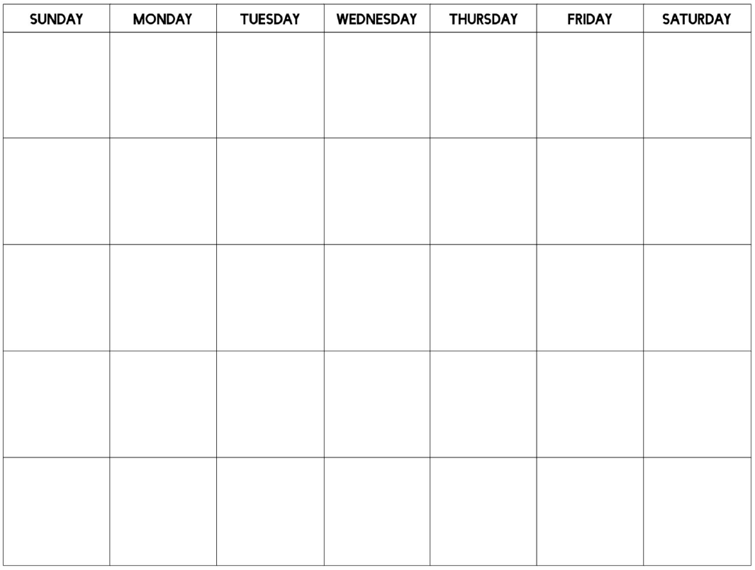

After your monthly workout plan is complete, please write a summary describing how you applied the above training principles to your workout. This can be completed in Word and attached to this packet.